12.80: Outside the planet it behaves like a point mass, so at the surface:

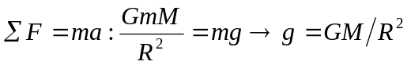

Get
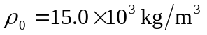at the center at the surface, 